November 10, 2010

Kingsley Azubike

Federal Highway Administration

**228 Walnut Street, Room 508  
Harrisburg, PA 17101-1720**

Re: Contract No. 510602

Project No. PSU 032

SPR Funding Approval

Dear Mr. Azubike:

Attached for your review and approval is the scope of work and budget for Work Order PSU 032, “Development of Guidelines for Usage of High Percent RAP in Warm Mix Asphalt Pavements”, under the PennDOT/Penn State University Intergovernmental Agreement No. 510602.

We are requesting State Planning and Research funding approval for $93,180.96 to support this eleven (11) month project.

If you have any questions please feel free to call me. Thank you for your time and review of this worthwhile research request.

Sincerely,

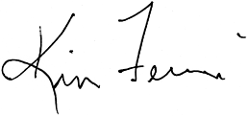

Kim Ferroni

Contract Administrator

Bureau of Planning and Research